INTRODUCTION
All the MS have a lot of properties file entries. If all any of the one property is changed changes need to be made in all of the MS application.properties.

Options:
- Env Variables – Limited number of variables
- External File – Accessing a such a file system will be difficult
- External Config server

One Server Config Server with centralized properties:
All the MS must read from that server.

Implementations:
Can be done via:
- Spring Cloud Consul
- Spring Cloud Config
- ZooKeeeper

Spring Cloud Consul:
The consul server shares all the properties to all the MS during bootstrap phase.
INSTALLATION OF CONSUL
Step 1: Install Consul.
Download consul.exe from https://developer.hashicorp.com/consul/install.
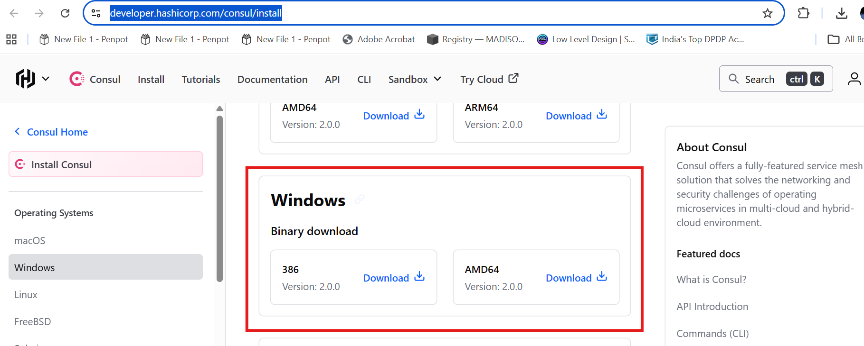
Extract the zip. And open a cmd terminal from the same path.
Then in command prompt execute below command to start and run the consul agent. Consul agent is the core process of consul.

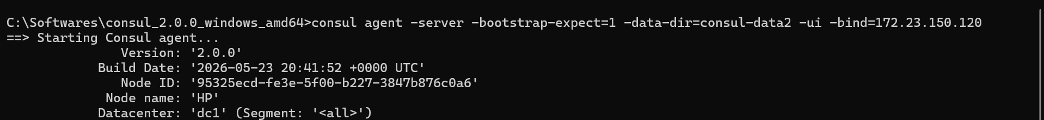
Command used is :
consul agent -server -bootstrap-expect=1 -data-dir=consul-data2 -ui -bind=172.23.150.120

Explanation of the command:
- -server : Indicates consul is acting as a server. Consul can act both as a server or as a client.
- -bootstrap-expect=1 : Indicates the number of instances of server. Consul can be used to setup cluster also.

- -data-dir: the path where all the consul related data will be stored. Where will this be created s? The dir will be in the same path where consul.exe is present currently.

- -ui: To enable the web ui for consul for us to perform our activities.

- -bind=172.23.150.120 is the IP of the machine

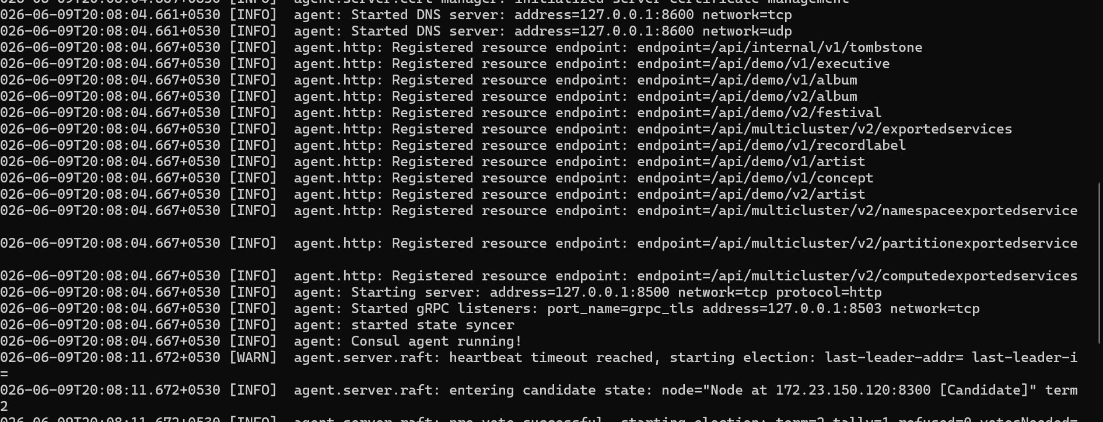

After successfully starting you will see the Consul agent running! Message.

To access the ui:
http://localhost:8500/ui/

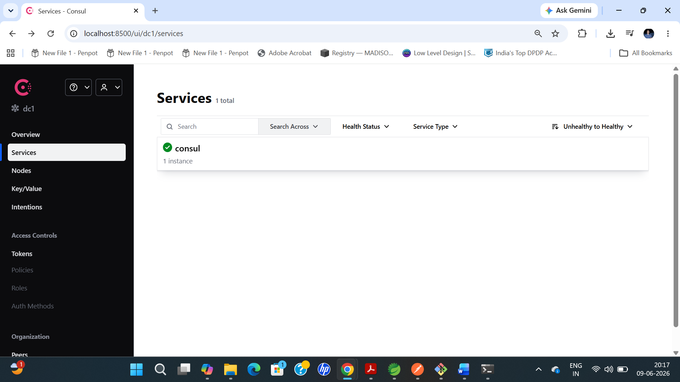

With this we have successfully installed consul.

USING CONSUL

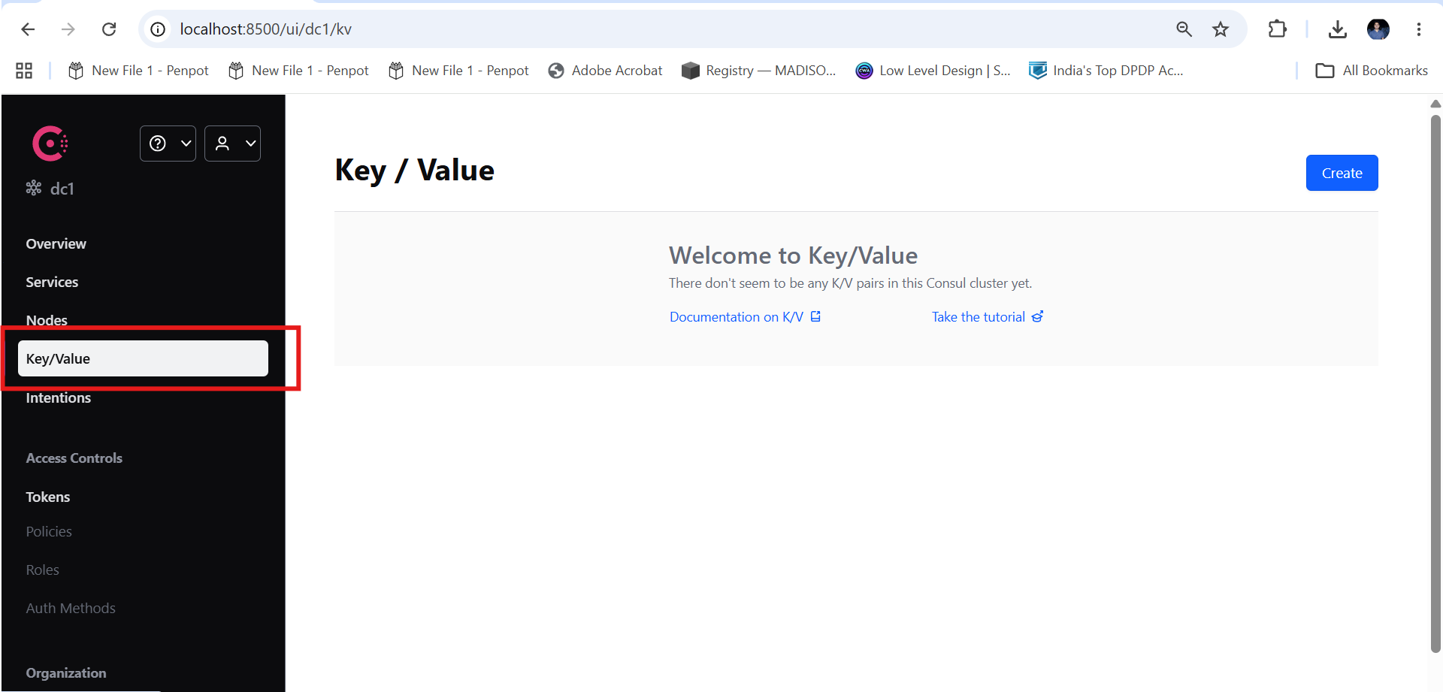

Consul provides a key value store to store the config details or metadata.
We need to make use of this feature available from consul to setup.

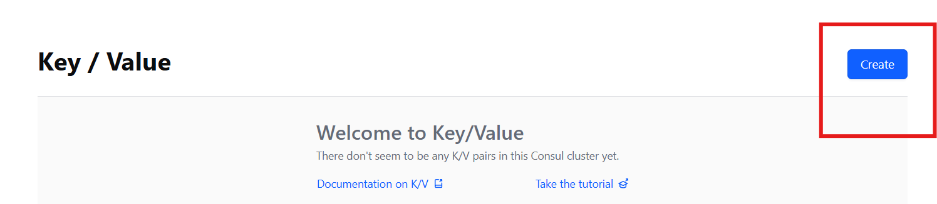

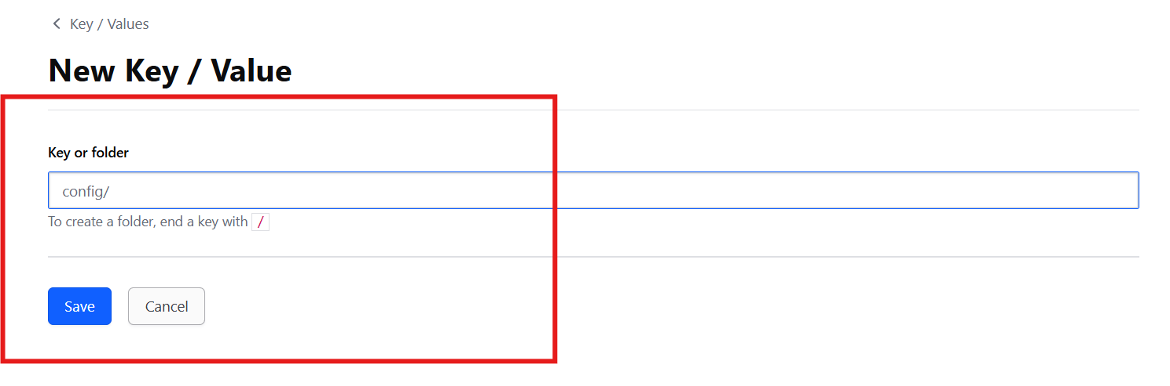

By Default the configurations are stored in this config folder. So start with config/

Now the properties can further be classified into two types:
- Common properties across all microservices
- Properties specific to a MS

Configuring Common Props
All common props in config/application/data

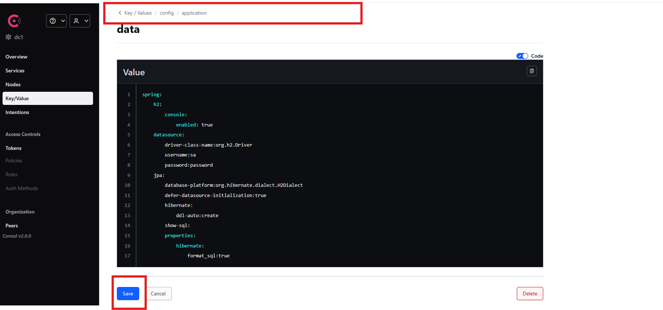

Click on the save
Configuring Microservice Props

Now creation of MS specific props

Inside config folder create a folder with the same name as that of the MS. This is mandatory.

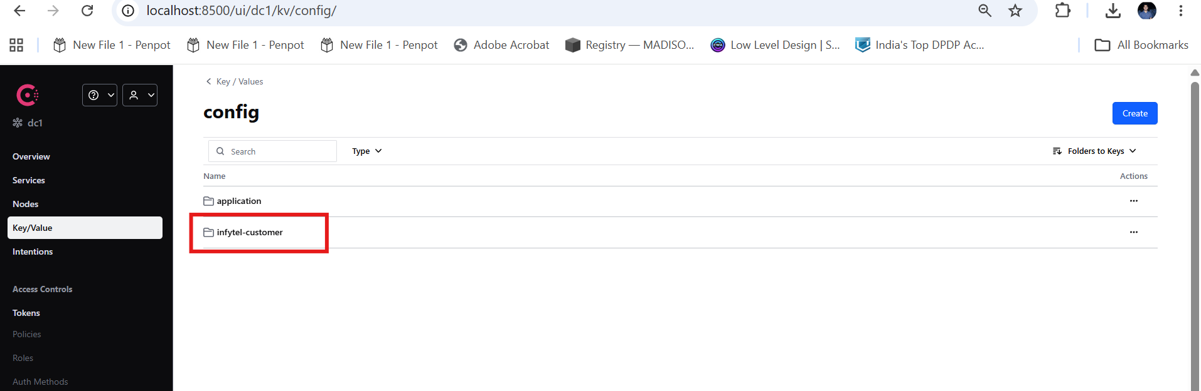

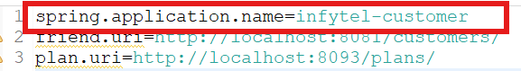

Added Microservice specific properties:

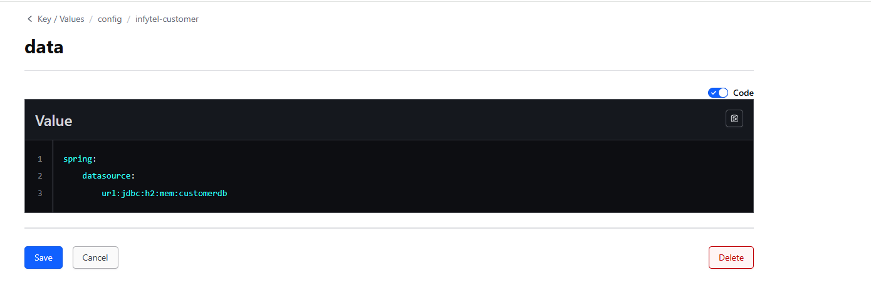

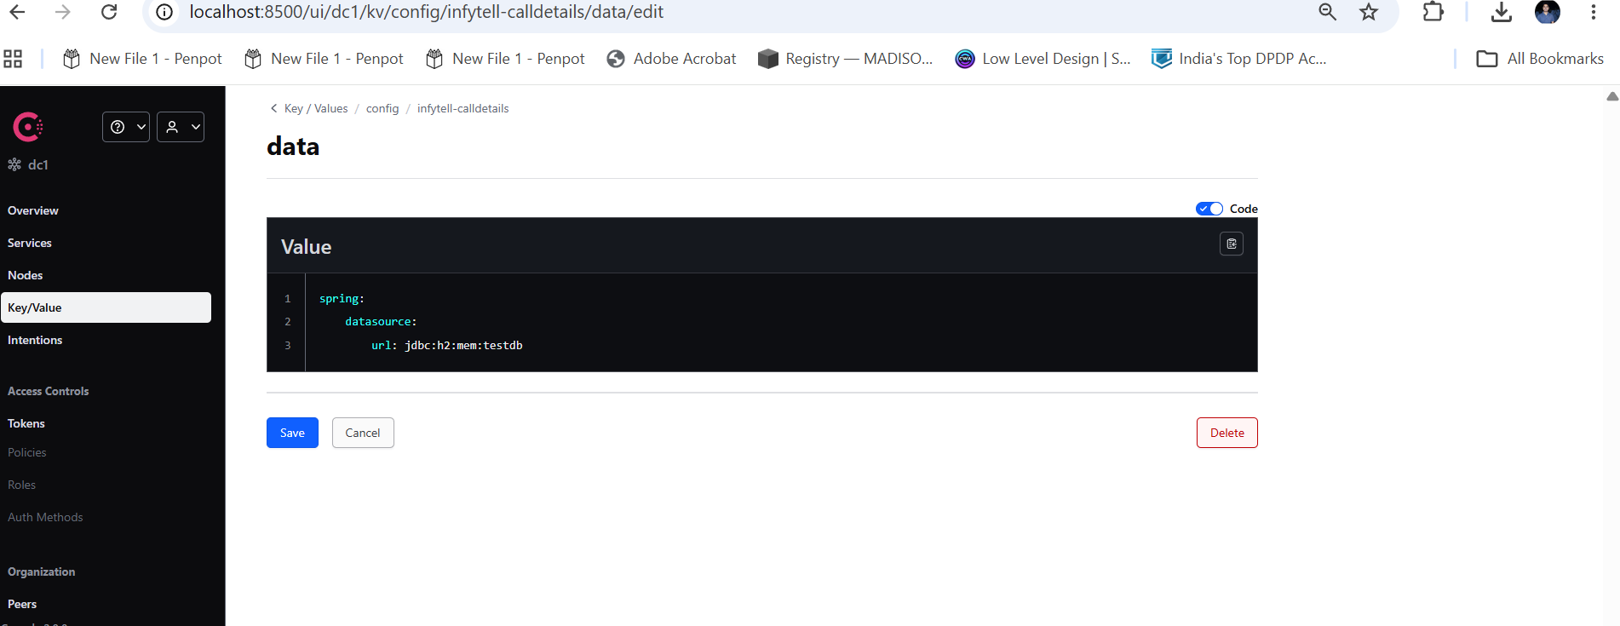

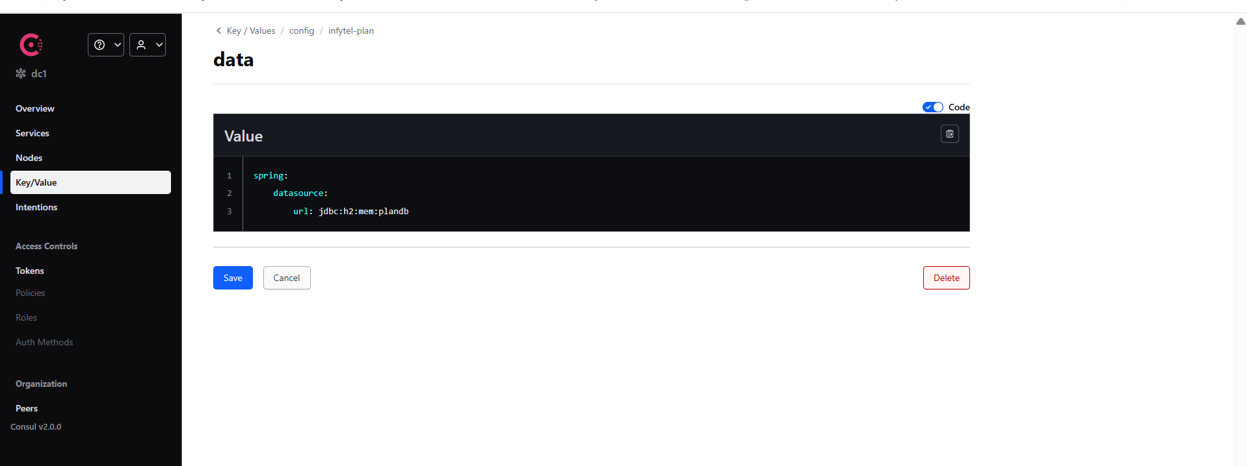

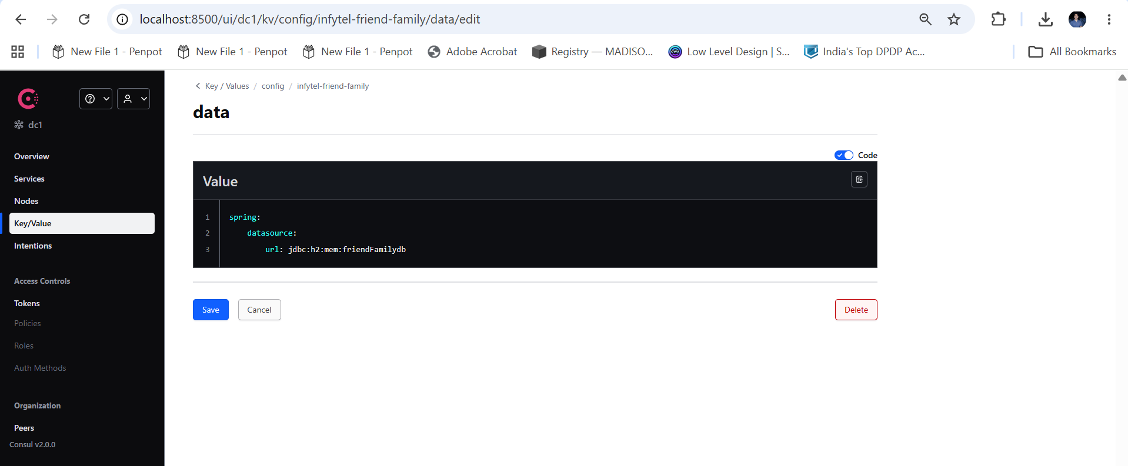

All the required properties have been moved to the respective data file of the respective folder dedicated to each of the diff MS.

MICROSERVICES CHANGES

Now we need to ensure that all the MS uses these dependencies as well. To implement that we now have to include the required dependencies:

<dependency>
<groupId>org.springframework.cloud</groupId>
<artifactId>spring-cloud-starter-consul</artifactId>
<version>5.0.0</version>
</dependency>

Add the above dependency in all the MS which needs to talk to the consul.

Add the below properties in application.properties:
spring.application.name=infytell-calldetails
server.port=8092
spring.config.import=consul:
spring.cloud.consul.config.format=YAML

Note bootstrap.yml is not needed at all. But the above four properties must definitely be part of application.properties.
Also the consul key-value store must have the correct naming convention i.e.
- config/application/data – For the common configurations
- config/{spring.application.name}/data – service specific properties

